**NATURAL RESOURCES DEPARTMENT**

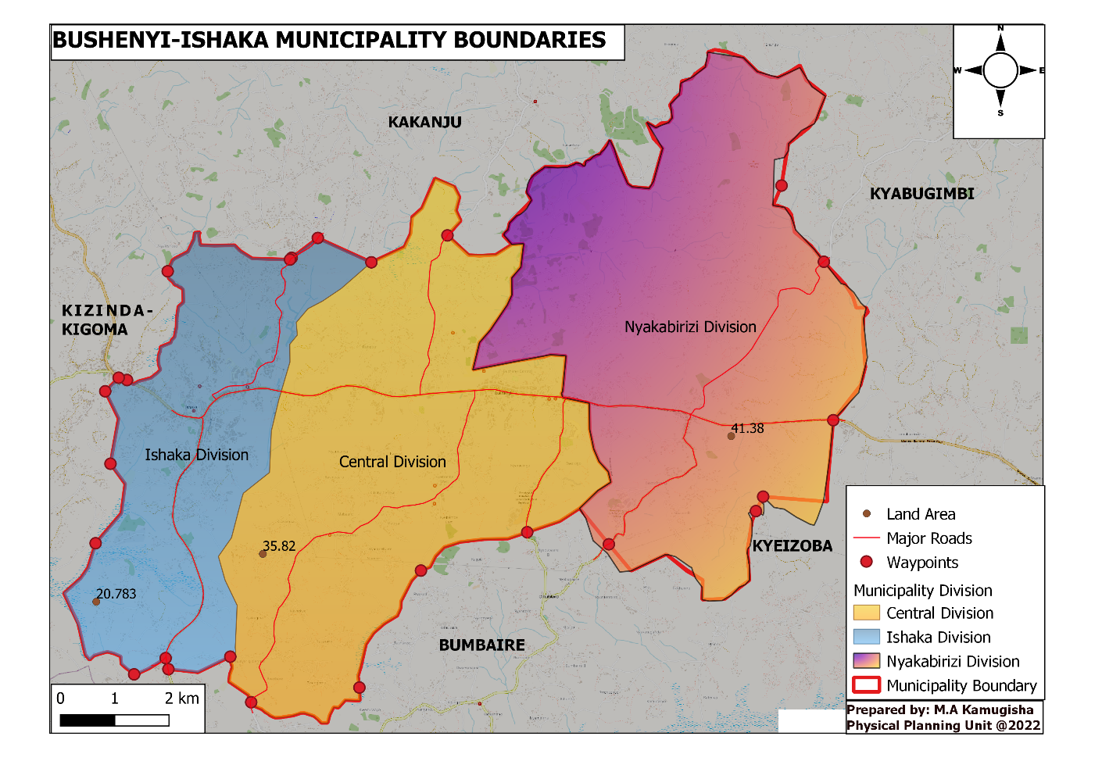

**Vision**

To attain orderly and enhance sustainable land use and environment management for orderly urban development

**Mission**

To ensure adequately planned utilization of urban land by providing proper guidance to developers and land users in line with laws and regulations

**Sections**

The department is comprised of two main sections – Lands and Physical Planning Unit and Environment. The Lands and Physical Planning Unit is headed by the Senior Physical Planner Mr. Michael Ahumuza Kamugisha and the Environment Section is headed by Senior Environment Officer Mr. Abbot Mwebaze.

**Core functions of the Department**

* Plan and design Municipal Physical Infrastructure, including re-zoning, land subdivision and determination of the areas of development
* Plan, conduct surveying and mapping, delineate the areas for social infrastructure and survey of Municipal lands and boundaries
* Consider, offer guidance to developers and approve development permissions
* Prepare development schemes/plans to guide Municipality development and land use
* Inspection, monitoring of all land based developments to ensure that they conform to approved

planning schemes, laws, standards and regulations

* Conduct environmental monitoring and appraisal of development activities
* Facilitate the registration of un registered lands
* Restoration of fragile ecosystem
* Offer environment education services
* Implement sound and sustainable Natural resources (Water, wetlands, forests and biodiversity) conservation and management.
* Develop and implement a public/community participation action plan in environment management.
* Develop proposals, implement and participate in environmental management basic and applied research to inform strategic decisions and policy
* Offer technical advice on appropriate environment management at all levels.
* Provide technical support to BIMC in integrating Best practices of Environmental Management and Climate Change in Infrastructure development, gender and community services, spatial planning, Education and other key municipal development projects.